**SRM INSTITUTE OF SCIENCE AND TECHNOLOGY**

**DEPARTMENT OF COMPUTER SCIENCE AND ENGINEERING**

**KATTANKULATHUR – 603 203**

**15IT304J- Web Programming Register Number: RA1711003011471**

**Name: Manvi Singh Chandel**

**Experiment No: 4**

**Date: 03/09/2020**

**Aim:** **Write an XML document to display information.**

**Input:**

<html>  
<head>  
<style>  
table, th, td {  
  border: 1px solid black;  
  border-collapse:collapse;  
}  
th, td {  
  padding: 5px;  
}  
</style>  
</head>  
<body>  
  
<table id="demo"></table>  
  
<script>  
function loadXMLDoc() {  
  var xmlhttp = new XMLHttpRequest();  
  xmlhttp.onreadystatechange = function() {  
    if (this.readyState == 4 && this.status == 200) {  
      myFunction(this);  
    }  
  };  
  xmlhttp.open("GET", "cd_catalog.xml", true);  
  xmlhttp.send();  
}  
function myFunction(xml) {  
  var i;  
  var xmlDoc = xml.responseXML;  
  var table="<tr><th>Artist</th><th>Title</th></tr>";  
  var x = xmlDoc.getElementsByTagName("CD");  
  for (i = 0; i <x.length; i++) {  
    table += "<tr><td>" +  
    x[i].getElementsByTagName("ARTIST")[0].childNodes[0].nodeValue +  
    "</td><td>" +  
    x[i].getElementsByTagName("TITLE")[0].childNodes[0].nodeValue +  
    "</td></tr>";  
  }  
  document.getElementById("demo").innerHTML = table;  
}  
</script>  
  
</body>  
</html>

**OUTPUT:-**

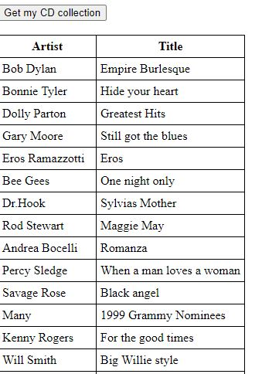

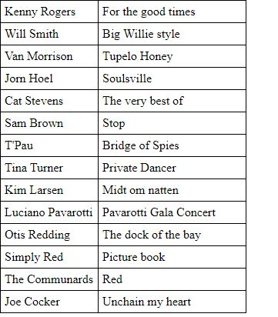

**Result: Information was displayed using the XML file**